IEP & Language: What Parents & Caregivers Need to Know  Looking at both impact and experience through the IEP process for parents and what can Educators do to support students effectively through these meetings via language and relationship while building collaboration with parents using empathy as a driver.  Facilitator:  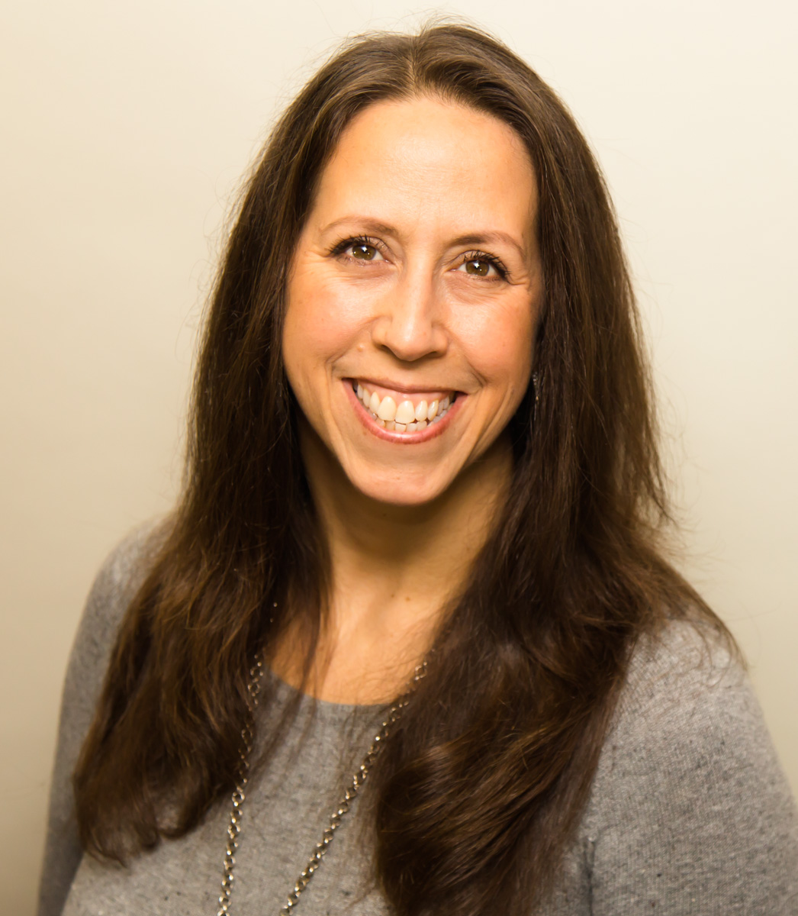  As a Counsellor and TEDx speaker, Suzanne Perreault identifies as a Metis Autistic who draws from lived and professional experience to support the lives of families with neurodiversities. She is a strong advocate for children facing barriers of Inclusion locally and regionally. Suzanne has been an active participant in community development and mentorship for over 18 years. Currently she is a Counsellor, and Inclusive Ed Consultant supporting provincial Districts in the conversation of Inclusion and Trauma Informed Practices to include being a return guest presenter with SFU teacher candidates and at UFV within the Child and Youth Care program. As a founding task force member of BCEdAcess Society, Suzanne recently participated in the COVID19 outreach talks supported by the Canadian Red Cross. Suzanne has positioned herself as a strong collaborator to create bridges for inclusion with a primary focus on fair and equitable access for students in education. Her steps demonstrate a strong passion for both equity and community relationships. #InclusionMatters  Date: Thursday October 7th  6:30 to 8:00  Via Zoom  Pre-registration Required:  https://us02web.zoom.us/meeting/register/tZEufu-qrDsjHdMaHp7uI-SA2ikgPO26HOaZ  After registering, you will receive a confirmation email containing information about joining the workshop. |  | PRESENTED BY:  a free  education series for parents and caregivers  iep & Language  Nov  BN  Suzanne Perreault  Pre-Registration  required  6  No  Thursday  October 7th  6:30-8pm  Via Zoom

